4.User scenarios/Use cases

UC Name | UC001-Create User Accounts
Summary | Administrator creates accounts for landlords, tenants, operators, and maintenance staff.
Dependency | None
Actors | Primary:Administrator
Preconditions | Administrator is logged into the system with admin privileges.
Description of the Main Sequence | Step 1: Admin selects Create User.  Step 2: Admin enters user details and role.  Step 3: System validates and saves account.
Description of the Alternative Sequence | Step 1: Invalid or missing data entered.  Step 2: System displays error message.
Non functional requirements | Secure data storage and fast validation.
Postconditions | New user account exists in the system.

UC Name | UC002-Assign Roles and Permissions
Summary | Administrator assigns system roles and permissions.
Dependency | Depends on UC001-Create User Accounts
Actors | Primary:Administrator
Preconditions | User account exists.
Description of the Main Sequence | Step 1: Admin selects user.  Step 2: Admin assigns role and permissions.  Step 3: System updates access rights.
Description of the Alternative Sequence | Step 1: Invalid role selected.  Step 2: System shows warning.
Non functional requirements | Role changes must be logged.
Postconditions | User permissions updated.

UC Name | UC003-Manage System Settings
Summary | Administrator configures policies, notifications, and operational settings.
Dependency | None
Actors | Primary:Administrator
Preconditions | Admin is authenticated.
Description of the Main Sequence | Step 1: Admin opens system settings.  Step 2: Admin updates configuration.  Step 3: System saves changes.
Description of the Alternative Sequence | Step 1: Invalid configuration entered.  Step 2: System rejects changes.
Non functional requirements | High availability and secure access.
Postconditions | System configuration updated.

UC Name | UC004-Monitor System Usage
Summary | Administrator views user activity and login tracking.
Dependency | Depends on UC001-Create User Accounts
Actors | Primary:Administrator
Preconditions | System logging is enabled.
Description of the Main Sequence | Step 1: Admin opens activity dashboard.  Step 2: Admin reviews logs and usage data.
Description of the Alternative Sequence | Step 1: No data available.  Step 2: System shows empty report.
Non functional requirements | Real-time monitoring performance.
Postconditions | Admin gains system usage insights.

UC Name | UC005-Receive System Alerts
Summary | Administrator receives alerts about errors and failures.
Dependency | Depends on UC003- Manage System Settings
Actors | Primary:Administrator
Preconditions | Alert system is configured.
Description of the Main Sequence | Step 1: System detects issue.  Step 2: System sends alert to admin.
Description of the Alternative Sequence | Step 1: Notification fails.  Step 2: System retries delivery.
Non functional requirements | High reliability notifications.
Postconditions | Admin is informed of system issues.

UC Name | UC006-Generate System Reports
Summary | Administrator generates reports for activity, income, and payments.
Dependency | Depends on UC004- Monitor System Usage
Actors | Primary:Administrator
Preconditions | Admin is logged in.
Description of the Main Sequence | Step 1: Admin selects report type.  Step 2: System generates report.  Step 3: Admin downloads or views report.
Description of the Alternative Sequence | Step 1: No data found.  Step 2: System shows message..
Non functional requirements | Reports generated quickly and securely.
Postconditions | Report available to admin.

UC Name | UC007-Approve Lease and Fee Policies
Summary | Administrator approves system-wide lease and fee rules.
Dependency | Depends on UC003- Manage System Settings
Actors | Primary:Administrator
Preconditions | Policies submitted for approval.
Description of the Main Sequence | Step 1: Admin reviews policy.  Step 2: Admin approves policy.  Step 3: System publishes policy.
Description of the Alternative Sequence | Step 1: Admin rejects policy.  Step 2: System returns policy for revision..
Non functional requirements | Audit trail of approvals.
Postconditions | Approved policies become active.

UC Name | UC008 – Approvement or rejection of property lease
Summary | Property Owner approves or rejects the property lease
Dependency | Property must exist in the system
Actors | Primary: Property Owner
Preconditions | Owner is logged in; Property listing exists; Lease approved
Description of the Main Sequence | • Navigate to My Properties  • Select property  • The term and conditions are met or not  • Confirm action  • System updates status
Description of the Alternative Sequence | • Cancel action → No changes made
Nonfunctional requirements | Secure and fast response
Postconditions | Property is no longer rentable

UC Name | UC009: Deactivate/Remove Property Listing
Summary | Property Owner removes or deactivates an existing property listing
Dependency | Property must already exist in the system
Actors | Primary: Property Owner
Preconditions | Owner is logged in; Property listing exists
Description of the Main Sequence | • Navigate to My Properties  • Select property  • Choose deactivate/remove  • Confirm action  • System updates status
Description of the Alternative Sequence | • Cancel action → No changes made
Nonfunctional requirements | Secure and fast response
Postconditions | Property is no longer visible

UC Name | UC010
Summary | View rental income and payment history
Dependency | Payment records must exist
Actors | Primary: Property Owner
Preconditions | Owner is logged in
Description of the Main Sequence | • Open dashboard  • Select month  • View income  • View history
Description of the Alternative Sequence | • No data → Show empty report
Nonfunctional requirements | Fast and accurate
Postconditions | Owner views financial data

UC011 – Define Lease Terms & Conditions
UC Name | UC011
Summary | Define lease terms
Dependency | Property must exist
Actors | Primary: Property Owner
Preconditions | Owner logged in
Description of the Main Sequence | • Select property  • Enter lease duration  • Define rules  • Save
Description of the Alternative Sequence | • Invalid input → Error
Nonfunctional requirements | Secure storage
Postconditions | Lease terms saved

UC Name | UC012
Summary | Set rental price
Dependency | Property exists
Actors | Primary: Property Owner
Preconditions | Logged in
Description of the Main Sequence | • Select property  • Enter price  • Save
Description of the Alternative Sequence | • Invalid input → Reject
Nonfunctional requirements | Validation required
Postconditions | Price updated

UC Name | UC013
Summary | Track leases and expiry
Dependency | Leases exist
Actors | Primary: Property Owner
Preconditions | Logged in
Description of the Main Sequence | • Open leases  • View list  • Check expiry
Description of the Alternative Sequence | • No leases → Empty list
Nonfunctional requirements | Accurate dates
Postconditions | Lease status known

UC Name | UC014
Summary | Approve/reject maintenance requests
Dependency | Requests exist
Actors | Primary: Property Owner, Secondary: Tenant
Preconditions | Logged in
Description of the Main Sequence | • View requests  • Select request  • Approve
Description of the Alternative Sequence | • Reject request
Nonfunctional requirements | Notifications
Postconditions | Request updated

UC Name | UC015 – Approve Lease Renewal
Summary | Property Owner approves lease renewals and updates lease terms.
Dependency | Depends on existing lease records.
Actors | Primary: Property Owner
Preconditions | Lease exists and is eligible for renewal.
Description of the Main Sequence | Step 1: Owner logs in  Step 2: Navigates to lease management  Step 3: Selects lease  Step 4: Reviews details  Step 5: Updates terms  Step 6: Approves renewal
Description of the Alternative Sequence | Step 1: Owner rejects renewal  Step 2: System notifies tenant
Non functional requirements | Secure access, fast response time.
Postconditions | Lease is renewed or rejected.

UC Name | UC016 – View Lease Expirations & Vacancies
Summary | Owner views lease expirations and vacant properties.
Dependency | Depends on lease/property database.
Actors | Primary: Property Owner
Preconditions | Owner is logged in.
Description of the Main Sequence | Step 1: Login  Step 2: Open dashboard  Step 3: View expirations  Step 4: View vacancies
Description of the Alternative Sequence | No data available → system shows empty message
Non functional requirements | Real-time data, user-friendly UI.
Postconditions | Owner sees leases and vacancies.

UC Name | UC017 – Monitor Tenant Compliance
Summary | Owner monitors tenant compliance.
Dependency | Depends on tracking system.
Actors | Primary: Property Owner
Preconditions | Tenant lease is active.
Description of the Main Sequence | Step 1: Login  Step 2: Access tenant records  Step 3: Review compliance  Step 4: Identify violations
Description of the Alternative Sequence | No violations → system confirms compliance
Non functional requirements | Accurate tracking, secure data.
Postconditions | Compliance status is known.

UC Name | UC018 – Tenant Registration
Summary | Tenant creates account.
Dependency | None
Actors | Primary: Tenant
Preconditions | Internet access.
Description of the Main Sequence | Step 1: Open registration  Step 2: Enter details  Step 3: Submit  Step 4: Account created
Description of the Alternative Sequence | Invalid data → error message
Non functional requirements | Secure password handling.
Postconditions | Account created.

UC Name | UC020 – Search Properties
Summary | Tenant searches properties.
Dependency | Depends on property database.
Actors | Primary: Tenant
Preconditions | Properties exist.
Description of the Main Sequence | Step 1: Open search  Step 2: Apply filters  Step 3: View results
Description of the Alternative Sequence | No results → system shows message
Non functional requirements | Fast search, accurate filtering.
Postconditions | Properties displayed.

UC Name | UC022 – Pay Rent Online
Summary | Tenant pays rent online.
Dependency | Payment gateway.
Actors | Primary: Tenant, Secondary: Payment System
Preconditions | Active lease, payment method.
Description of the Main Sequence | Step 1: Login  Step 2: Go to payments  Step 3: Enter details  Step 4: Confirm  Step 5: Payment processed
Description of the Alternative Sequence | Payment fails → retry
Non functional requirements | Secure payments, reliability.
Postconditions | Payment recorded.

UC Name | UC-023: Tenant Requests Lease Renewal
Summary | Tenant submits a request to renew their lease. The property manager reviews and approves or rejects it.
Dependency | Depends on FR017 - Property Owner approves tenant compliance with lease terms
Actors | Primary Actor: Tenant  Secondary Actor: Property Manager
Preconditions | Tenant has an active lease eligible for renewal.  Tenant is logged in.
Description of the Main Sequence | - Tenant selects “Renew Lease” in the system.  - Tenant submits the renewal request.  - System notifies the property manager.  - Property manager approves or rejects the request.  - System informs the tenant of the decision.
Description of the Alternative Sequence | - Lease not eligible: System shows an error and cannot submit the request.  - Tenant cancels: System discards the request.
Non functional requirements | Requests processed quickly (≤2 seconds).  Only authenticated tenants can submit.  Data must be secure and encrypted.
Postconditions | Renewal request is recorded.  Tenant is notified of approval or rejection.

UC Name | UC-024: Tenant Acknowledges Move-Out
Summary | This use case describes how a tenant reviews and acknowledges the required move-out procedures before leaving the property.
Dependency | Depends on FR013: Property Owner tracks lease agreements and expiry dates
Actors | Primary Actor: Tenant  Secondary Actors: Property Owner, System
Preconditions | Tenant has an active lease that is near expiration  Tenant is logged into the system  Move-out instructions are available
Description of the Main Sequence | - System notifies the tenant about upcoming lease expiration and move-out process.  - Tenant logs into the system.  - Tenant navigates to the “Move-Out” section.  - System displays move-out procedures and requirements.  - Tenant reviews the instructions.  - Tenant confirms acknowledgment.  - System records the acknowledgment and updates the status.
Description of the Alternative Sequence | Tenant does not acknowledge: Tenant views instructions but does not confirm.  Tenant not notified: Notification fails or is missed.
Non functional requirements | Performance: Page and confirmation should load within 2 seconds  Usability: Instructions must be clear and easy to understand  Reliability: System should store acknowledgment without data loss
Postconditions | Tenant acknowledgment is stored in the system  Move-out process status is updated

UC Name | UC-025 Tenant Submits Review
Summary | This use case describes how a tenant submits a review and rating for a property after completing their lease.
Dependency
Actors | Primary Actor: Tenant  Secondary Actors: System
Preconditions | Tenant has completed the lease and moved out  Tenant is logged into the system  Review feature is available
Description of the Main Sequence | - Tenant logs into the system.  - Tenant selects the completed lease/property.  - System displays review form (rating + comments).  - Tenant enters rating and feedback.  - Tenant submits the review.  - System stores the review and links it to the property.
Description of the Alternative Sequence | Tenant cancels submission:  - Tenant opens review form but clicks cancel.  - System discards input and no review is saved.  Incomplete review submission:  - Tenant submits without required fields  - System shows validation error and requests completion.  System error during submission:  - Submission fails due to system issue.  - System shows error and asks tenant to retry.
Non functional requirements | Usability: Review form must be simple and quick to complete  Performance: Submission should process within 2 seconds  Security: Only verified tenants can submit reviews
Postconditions | Review is stored in the system  Property owner can view the submitted review

UC Name | UC-026 Tenant Views Property Details
Summary | This use case describes how a tenant views detailed information about a property listed in the system.
Dependency | Depends on FR020: Tenant searches for available properties  Depends on FR012: Property Owner sets rental prices
Actors | Primary Actor: Tenant  Secondary Actors: System
Preconditions | Tenant is logged into the system  Properties are available in the system
Description of the Main Sequence | - Tenant searches for properties using filters  - System displays a list of available properties.  - Tenant selects a specific property.  - System displays detailed information  - Tenant reviews the property details.
Description of the Alternative Sequence | No properties found:  - Tenant performs a search.  - System shows “no results found” message.  Property unavailable:  - Tenant selects a property that is no longer available.  - System displays availability error message.  System error:  - Property details fail to load.  - System shows error and prompts retry.
Non functional requirements | Performance: Property details should load within 2 seconds  Usability: Interface should be clear and easy to navigate  Compatibility: Must work on mobile, tablet, and desktop
Postconditions | Property details are displayed to the tenant

UC Name | UC-027 Tenant Signs Lease Online
Summary | This use case describes how a tenant reviews and digitally signs a lease agreement through the system.
Dependency | Depends on FR008: Property Owner approves lease applications  Depends on FR011: Property Owner defines lease terms and conditions
Actors | Primary Actor: Tenant  Secondary Actors: Property Owner, System
Preconditions | Tenant’s lease application has been approved  Lease agreement is available in the system  Tenant is logged in
Description of the Main Sequence | - System notifies the tenant that the lease is ready for signing.  - Tenant logs into the system.  - Tenant navigates to the lease section.  - Tenant opens and reviews the lease document.  - Tenant accepts terms and signs the lease digitally.  - System stores the signed agreement.  - System notifies the property owner.
Description of the Alternative Sequence | Tenant declines lease:  - Tenant reviews lease but does not accept terms.  - System cancels the signing process and notifies the owner.  Incomplete signing:  - Tenant exits before signing.  - System keeps status as “Pending signature.”  System error during signing:  - Error occurs while saving signature.  - System shows error and requests retry.
Non functional requirements | Security: Digital signature and documents must be securely stored  Performance: Lease should load and save within 2–3 seconds  Reliability: No data loss during signing process
Postconditions | Lease agreement is signed and stored  Lease status is updated to active

UC Name | UC-028 Tenant Submits Maintenance Request
Summary | This use case describes how a tenant reports a maintenance or repair issue for their rented property.
Dependency | Depends on FR013: Property Owner tracks lease agreements  Depends on FR039: Operator forwards maintenance requests  Depends on FR052: Maintenance staff view tasks
Actors | Primary Actor: Tenant  Secondary Actors: Operator, Property Owner, Maintenance Staff, System
Preconditions | Tenant has an active lease  Tenant is logged into the system  Maintenance feature is available
Description of the Main Sequence | - Tenant logs into the system..  - Tenant fills in issue details.  - Tenant submits the request.  - System records the request and notifies the operator.  - Operator reviews and forwards the request to maintenance staff.  - Maintenance staff receive and view the task.
Description of the Alternative Sequence | Incomplete request:  - Tenant submits form with missing details.  - System shows validation error and requests completion.  Tenant cancels request:  - Tenant exits before submitting.  - No request is recorded.  System error:  - Submission fails due to system issue.  - System shows error and asks tenant to retry.
Non functional requirements | Performance: Request submission within 2 seconds  Usability: Form should be simple and easy to fill  Reliability: Requests must be stored without loss
Postconditions | Maintenance request is recorded  Relevant actors are notified

UC Name | UC-029 Tenant Views Payment History and Balances
Summary | This use case describes how a tenant views their past payments and any outstanding balances
Dependency | Depends on FR022: Tenant makes monthly rent payments online  Depends on FR050: Accountant tracks all received payments
Actors | Primary Actor: Tenant  Secondary Actors: Accountant, System
Preconditions | Tenant is logged into the system  Payment records exist
Description of the Main Sequence | - Tenant logs into the system.  - Tenant navigates to the “Payments” or “Billing” section.  - Tenant selects “Payment History.”  - System retrieves payment records.  - System displays past payments and current balance.  - Tenant reviews the information.
Description of the Alternative Sequence | No payment records:  - Tenant accesses payment history.  - System shows “no records available.”  System error:  - Data fails to load.  - System displays error and prompts retry.  Unauthorized access attempt:  - User not properly authenticated.  - System denies access and requests login.
Non functional requirements | Performance: Data should load within 2–3 seconds  Security: Only authorized tenants can view payment data  Accuracy: Payment data must be correct and up-to-date
Postconditions | Payment information is displayed to the tenant

UC Name | UC-030 Tenant Receives Notifications
Summary | This use case describes how the system sends notifications to tenants about important events such as rent due dates, lease renewals, and maintenance updates.
Dependency | Depends on FR022: Tenant makes monthly rent payments  Depends on FR023: Tenant requests lease renewal  Depends on FR028: Tenant submits maintenance requests
Actors | Primary Actor: System  Secondary Actors: Tenant
Preconditions | Tenant has an active account  Relevant events (payment due, renewal, maintenance update) exist
Description of the Main Sequence | - System detects a trigger event (rent due, lease expiry, status update).  - System generates a notification message.  - System sends notification (app, email, or SMS).  - Tenant receives the notification.  - Tenant opens and reads the notification.
Description of the Alternative Sequence | Notification delivery failure:  - System fails to send notification.  - System retries or logs the failure.  Tenant ignores notification:  - Notification is delivered but not opened.  - System may send reminders.  Incorrect contact info:  - Notification cannot be delivered.  - System flags issue for update.
Non functional requirements | Performance: Notifications should be sent in real-time or near real-time  Reliability: System should ensure delivery with retry mechanisms  Compatibility: Notifications should work across devices
Postconditions | Notification is sent and logged in the system  Tenant is informed about the event

Use Case Name | UC031 → Tenant communicates with operator about lease or maintenance issues
Summary | The tenant communicates with the operator to ask questions, or report issues related to their lease agreement or property maintenance needs.
Dependency | Use case depends on: UC028 – Tenant submits maintenance or repair request
Actors | Primary actor: Tenant  Secondary actor: Operator
Preconditions | The tenant has an active lease application.  Operator account is active.
Description of the Main Sequence | Step 1: Tenant logs into his account.  Step 2 Tenant navigates to the messaging section.  Step 3: Tenant selects the topic category (Lease / Maintenance Issue).  Step 4: Tenant submits the message or request.  Step 5: System records the communication and notifies the Operator.  Step 6: Operator reviews the submitted message.  Step 7: Operator responds to the message or request.
Description of the Alternative Sequence | Step 1: If invalid data entered → system requests tenant to complete information  Step 2: If the system is unavailable → system displays error message
Nonfunctional requirements | System should update data within 2 seconds.
Postconditions | The tenant receives confirmation that the message has been received.

Use Case Name | UC032 → Manage tenant applications and documentation.
Summary | The operator accesses, reviews, organizes and updates tenant application files and documentation through all the application stages.
Dependency | None
Actors | Primary actor: Operator
Preconditions | The tenant has submitted an application.  The operator is logged in his account.
Description of the Main Sequence | Step 1: Operator logs into his account.  Step 2: Operator selects a tenant application.  Step 3: System displays application displays.  Step 4: Tenant submits the message or request.  Step 5: Operator requests additional documentation if needed.  Step 6: Operator updates application status.  Step 7: System saves all changes.
Description of the Alternative Sequence | Step 1: If application not found → system shows error  Step 2: If system error occurs → changes are not saved
Nonfunctional requirements | Notifications should be sent instantly  Only authorized users can edit applications.
Postconditions | Status is updates. Documentation is stored and linked to the tenant record.

Use Case Name | UC033 → Communicates with tenants regarding lease terms.
Summary | The operator communicates with tenants through the system to provide information about lease terms, application approvals or rejections, and requests for additional documentation.
Dependency | Use case depends on: UC032 – Manage tenant application and documentation
Actors | Primary actor: Operator  Secondary actor: Tenant
Preconditions | The tenant has submitted an application.  The operator is logged in his account.
Description of the Main Sequence | Step 1: Operator logs into his account.  Step 2: Operator selects a tenant application.  Step 3: Operator submits a message to the tenant regarding lease terms.  Step 4: Tenant receives the message and responds to the operator.
Description of the Alternative Sequence | Step 1: If application not found → system shows error  Step 2: If tenant doesn’t respond → system sends reminder after a period of time
Nonfunctional requirements | Notifications should be sent instantly  System must ensure data integrity
Postconditions | Communication between operator and tenant is recorded.

Use Case Name | UC034 → Verifies tenant information and documents.
Summary | The operator reviews and validates the information and documents submitted by the tenant as part of their application to ensure authenticity.
Dependency | Use case depends on: UC033 – Communicate with tenants regarding lease terms
Actors | Primary actor: Operator  Secondary actor: Tenant
Preconditions | The tenant has submitted an application.  The operator is logged in his account.
Description of the Main Sequence | Step 1: Operator logs into his account.  Step 2: Operator selects a tenant application.  Step 3: Operator validates uploaded documents.  Step 4: Operator updates verification status.  Step 5: System saves updated results.
Description of the Alternative Sequence | Step 1: If application not found → system shows error  Step 2: If there are missing documents → system notifies tenant to upload required documents.  Step3: If system error during verification → changes are not saved
Nonfunctional requirements | Only authorized operators can verify documents.  Updates should be reflected in real-time.
Postconditions | Tenant information and documents are verified successfully.

Use Case Name | UC035 → Operator updates property availability status.
Summary | The operator updates the availability status of one or more properties based on lease approvals, rejections, tenant move-ins, move-outs, or other changes
Dependency | None.
Actors | Primary actor: Operator
Preconditions | Property listing exists in the system.  Operator has permission to modify property status.
Description of the Main Sequence | Step 1: Operator logs into his account.  Step 2: Operator selects a property record.  Step 3: Operator updates property status.  Step 4: System saves updated property availability.
Description of the Alternative Sequence | Step 1: If property not found → system shows error  Step 2: If system error during update → changes are not saved
Nonfunctional requirements | Only authorized operators can verify documents.  Updates should be reflected in real-time.
Postconditions | Property availability status is updated successfully.

Use Case Name | UC036 → Operator responds to tenant inquiries.
Summary | The operator responds to inquiries submitted by tenants regarding lease agreements, property information, payments, maintenance issues, or general support requests
Dependency | Use case depends on: UC031 – Communicate with operator regarding lease or maintenance issues
Actors | Primary actor: Operator  Secondary actor: Tenant
Preconditions | Tenant inquiry exists in the system.  Operator has permission to review and respond to tenant inquiries.
Description of the Main Sequence | Step 1: Operator logs into his account.  Step 2: Operator selects an inquiry to review.  Step 3: Operator sends response to the tenant.  Step 4: System sends notification to tenant.
Description of the Alternative Sequence | Step 1: If incomplete inquiry information → system requests clarification  Step 2: If system error during response → system displays error message
Nonfunctional requirements | Only authorized operators can respond.  Notifications should be sent instantly.
Postconditions | Tenant receives operator response.

UC Name | UC037 – Update Lease Application Information and Status
Summary | This use case allows the Operator to update lease application details and modify its status (e.g., pending, approved, rejected)
Dependency | This use case depends on: UC032 – Manage Tenant Applications (application must exist)
Actors | Primary Actor: Operator
Preconditions | Operator is logged into the system  Lease application exists
Description of the Main Sequence | Step 1: Operator selects a lease application  Step 2: System displays application details  Step 3: Operator updates information and/or status  Step 4: Operator submits changes  Step 5: System validates and saves updates
Description of the Alternative Sequence | Step 1: If application not found → system shows error  Step 2: If invalid data entered → system prompts correction  Step 3: If system error occurs → changes are not saved
Non functional requirements | System should update data within 2 seconds  Only authorized users can edit applications
Postconditions | Lease application is updated successfully

UC Name | UC038 – Monitor Tenant Support Requests
Summary | Allows the Operator to monitor and track tenant support requests.
Dependency | None
Actors | Primary Actor: Operator
Preconditions | Operator is logged into the system
Description of the Main Sequence | Step 1: Operator opens support request dashboard  Step 2: System displays list of tenant requests  Step 3: Operator reviews request details  Step 4: Operator tracks status of requests
Description of the Alternative Sequence | Step 1: If no requests exist → system displays empty list  Step 2: If system fails → error message is shown
Non functional requirements | Requests should load within 3 seconds  Data must be securely accessible
Postconditions | Operator has visibility of all tenant support requests

UC Name | UC039 – Forward Maintenance Requests
Summary | Allows the Operator to forward maintenance or repair requests to the maintenance team.
Dependency | Depends on UC038 – Monitor Tenant Support Requests
Actors | Primary Actor: Operator  Secondary Actor: Maintenance Staff
Preconditions | Maintenance request exists  Operator is logged in
Description of the Main Sequence | Step 1: Operator selects a maintenance request  Step 2: Operator forwards the request to maintenance team  Step 3: System notifies maintenance staff  Step 4: Request status is updated
Description of the Alternative Sequence | Step 1: If request not found → system shows error  Step 2: If forwarding fails → system displays error
Non functional requirements | Notifications should be sent instantly  System must ensure data integrity
Postconditions | Maintenance team receives the request

UC Name | UC040 – Schedule Maintenance Tasks
Summary | Allows the Operator to schedule maintenance tasks for the maintenance team.
Dependency | Depends on UC039 – Forward Maintenance Requests
Actors | Primary Actor: Operator  Secondary Actor: Maintenance Staff
Preconditions | Maintenance request has been created  Operator is logged in
Description of the Main Sequence | Step 1: Operator selects a maintenance request  Step 2: Operator assigns date and time  Step 3: Operator schedules the task  Step 4: System notifies maintenance staff
Description of the Alternative Sequence | Step 1: If schedule conflict occurs → system prompts rescheduling  Step 2: If invalid date/time → system shows error
Non functional requirements | Scheduling updates should reflect immediately  Notifications must be reliable
Postconditions | Maintenance task is scheduled successfully

UC Name | UC041 – Coordinate Move-Ins and Move-Outs
Summary | Allows the Operator to manage tenant move-in and move-out processes.
Dependency | Depends on UC037 – Update Lease Application
Actors | Primary Actor: Operator  Secondary Actors: Tenant, Maintenance Staff
Preconditions | Lease is approved  Operator is logged in
Description of the Main Sequence | Step 1: Operator selects tenant lease  Step 2: Operator schedules move-in or move-out date  Step 3: Operator updates system records  Step 4: System notifies tenant and maintenance staff
Description of the Alternative Sequence | Step 1: If lease not found → system shows error  Step 2: If scheduling conflict → system prompts adjustment
Non functional requirements | Updates should be reflected in real-time  Notifications must be delivered promptly
Postconditions | Move-in or move-out is scheduled and recorded

UC Name | UC042 – Manage Rent Payment Records
Summary | Allows the Accountant to manage and track tenant rent payment records.
Dependency | None
Actors | Primary Actor: Accountant
Preconditions | Accountant is logged into the system  Payment data exists
Description of the Main Sequence | Step 1: Accountant accesses payment records  Step 2: System displays payment details  Step 3: Accountant reviews and updates records  Step 4: System saves updates
Description of the Alternative Sequence | Step 1: If no records found → system displays message  Step 2: If invalid update → system shows error
Non functional requirements | Step 1: If no records found → system displays message  Step 2: If invalid update → system shows error
Postconditions | Payment records are updated and accurate

UC Name | UC043 – Generate Tenant Invoices
Summary | Allows the Accountant to generate invoices for tenants.
Dependency | Depends on UC042 – Manage Rent Payment Records
Actors | Primary Actor: Accountant
Preconditions | Accountant is logged in  Tenant and payment data exist
Description of the Main Sequence | Step 1: Accountant selects tenant  Step 2: System retrieves payment details  Step 3: Accountant generates invoice  Step 4: System creates and stores invoice
Description of the Alternative Sequence | Step 1: If tenant not found → system shows error  Step 2: If data missing → system prompts correction
Non functional requirements | Invoice generation should take less than 3 seconds  Data must be accurate and secure
Postconditions | Invoice is successfully generated and stored

UC Name | UC044 – Track Late or Overdue Payments
Summary | This use case allows the Accountant to identify and track late or overdue tenant payments.
Dependency | Depends on: UC042 – Manage Monthly Rent Payment Records
Actors | Primary Actor: Accountant  Secondary Actors: Tenant
Preconditions | - Accountant is logged into the system  - Payment records exist
Description of the Main Sequence | - Step 1: Accountant accesses payment records  - Step 2: System displays all payments and due dates  - Step 3: System highlights overdue payments  - Step 4: Accountant reviews late payments
Description of the Alternative Sequence | - Step 1: If no overdue payments → system shows message  - Step 2: If data error occurs → system displays error
Non functional requirements | System updates overdue status in real time  Only authorized users can view financial data
Postconditions | Late or overdue payments are identified and recorded

UC Name | UC045 – Calculate Total Rental Income
Summary | This use case allows the Accountant to calculate total rental income over a selected period.
Dependency | Depends on: UC042 – Manage Monthly Rent Payment Records
Actors | Primary Actor: Accountant  Secondary Actors: Administrator, Property Owner
Preconditions | - Accountant is logged in  - Payment data exists
Description of the Main Sequence | - Step 1: Accountant selects time period  - Step 2: System retrieves payment data  - Step 3: System calculates total income  - Step 4: System displays results
Description of the Alternative Sequence | - Step 1: If no data exists → system shows message  - Step 2: If invalid period → system prompts correction
Non functional requirements | Calculation completed within 2 seconds  Data must be accurate and consistent
Postconditions | Total rental income is displayed

UC Name | UC046 – Process Payment Refunds
Summary | This use case allows the Accountant to process refunds for tenants.
Dependency | Depends on: UC050 – Confirm and Track Payments
Actors | Primary Actor: Accountant  Secondary Actors: Tenant
Preconditions | - Accountant is logged in  - Valid payment exists
Description of the Main Sequence | - Step 1: Accountant selects a payment  - Step 2: Accountant initiates refund  - Step 3: System verifies eligibility  - Step 4: System processes refund  - Step 5: System updates records
Description of the Alternative Sequence | - Step 1: If payment not found → system shows error  - Step 2: If refund not allowed → system denies request
Non functional requirements | Transactions must be secure  Refund processing must be reliable
Postconditions | Refund is completed and recorded

UC Name | UC047 – Send Payment Reminders
Summary | This use case allows the Accountant to send reminders for upcoming or overdue rent payments.
Dependency | Depends on: UC044 – Track Late Payments
Actors | Primary Actor: Accountant  Secondary Actors: Tenant
Preconditions | - Accountant is logged in  - Tenant contact details exist
Description of the Main Sequence | - Step 1: System identifies due/overdue payments  - Step 2: Accountant selects reminder option  - Step 3: System generates notification  - Step 4: System sends reminder
Description of the Alternative Sequence | - Step 1: If contact info missing → system shows error  - Step 2: If notification fails → system logs error
Non functional requirements | Notifications sent quickly  System ensures delivery reliability
Postconditions | Tenant receives reminder

UC Name | UC048 – Manage Security Deposits
Summary | This use case allows the Accountant to track and manage tenant security deposits.
Dependency | Depends on: UC042 – Manage Payments
Actors | Primary Actor: Accountant  Secondary Actors: Tenant, Property Owner
Preconditions | - Accountant is logged in  - Deposit records exist
Description of the Main Sequence | - Step 1: Accountant views deposit records  - Step 2: System displays details  - Step 3: Accountant updates status  - Step 4: System saves updates
Description of the Alternative Sequence | - Step 1: If record not found → system shows error  - Step 2: If invalid update → system prompts correction
Non functional requirements | Deposit records are updated
Postcondition | Deposit records are updated

UC Name | UC049 – Generate Financial Reports
Summary | This use case allows the Accountant to generate financial reports.
Dependency | This use case allows the Accountant to generate financial reports.
Actors | Primary Actor: Accountant  Secondary Actors: Administrator, Property Owner
Preconditions | - Accountant is logged in  - Financial data exists
Description of the Main Sequence | - Step 1: Accountant selects report type  - Step 2: System gathers data  - Step 3: System generates report  - Step 4: System displays or exports report
Description of the Alternative Sequence | - Step 1: If no data → system shows message  - Step 2: If generation fails → system shows error
Non functional requirements | Reports generated quickly  Data must be accurate
Postcondition | Report is generated

UC Name | UC050 – Confirm and Track Payments
Summary | This use case allows the Accountant to confirm and track all received payments.
Dependency | Depends on: UC022 – Make Rent Payment
Actors | Primary Actor: Accountant  Secondary Actors: Tenant
Preconditions | - Accountant is logged in  - Payment has been made
Description of the Main Sequence | - Step 1: System receives payment  - Step 2: Accountant reviews payment  - Step 3: System matches records  - Step 4: Accountant confirms payment  - Step 5: System updates status
Description of the Alternative Sequence | - Step 1: If mismatch → system flags issue  - Step 2: If duplicate → system alerts
Non functional requirements | Secure payment handling  Ensure data integrity
Postcondition | Payment is confirmed and recorded

UC Name | UC051 – Monitor Financial Overview
Summary | This use case allows the Accountant to monitor overall financial status.
Dependency | Depends on: UC045, UC044, UC046
Actors | Primary Actor: Accountant  Secondary Actors: Administrator
Preconditions | - Accountant is logged in  - Financial data exists
Description of the Main Sequence | - Step 1: Accountant opens dashboard  - Step 2: System displays income, balances, refunds  - Step 3: Accountant reviews data
Description of the Alternative Sequence | If data unavailable → system shows error
Non functional requirements | Dashboard loads quickly  Data updated in real time
Postcondition | Financial overview is displayed

UC Name | UC052 – View Assigned Maintenance Tasks
Summary | Maintenance staff view all tasks assigned to them.
Dependency | UC054 (Receive Notifications), User Authentication
Actors | • Primary: Maintenance Staff  • Secondary: Operator
Preconditions | • Maintenance staff is logged in  • Tasks have been assigned
Description of the Main Sequence | • Step 1: Staff logs into the system  • Step 2: System displays dashboard  • Step 3: Staff selects “View Tasks”  • Step 4: System displays assigned tasks
Description of the alternative sequence | • Step 1: No tasks assigned  • Step 2: System displays “No tasks available”
Non-functional requirements | • Task list loads within 2 seconds  • Data must be accurate and up to date
Postconditions | • Staff can view all assigned maintenance tasks

UC Name | UC053 – Update Task Status
Summary | Maintenance staff update task progress.
Dependency | UC052 (View Assigned Tasks)
Actors | Primary: Maintenance Staff
Preconditions | • Staff is logged in  •Task is assigned
Description of the Main Sequence | • Step 1: Staff selects a task  • Step 2: Staff selects status (Pending/In Progress/Completed)  • Step 3: System updates task status  • Step 4: System confirms update
Description of the alternative sequence | • Step 1: Invalid update or system error  • Step 2: System displays error message
Non-functional requirements | • Updates should be saved instantly  • System must ensure data integrity
Postconditions | Task status is updated successfully

UC Name | UC54 – Receive Maintenance Notifications
Summary | Maintenance staff receive alerts for new assignments
Dependency | UC039 (Operator forwards request), UC040 (Operator schedules tasks)
Actors | • Primary: Maintenance Staff  • Secondary: Operator
Preconditions | • Staff account is active  • Notification system is enabled
Description of the Main Sequence | • Step 1: Operator assigns maintenance task  • Step 2: System generates notification  • Step 3: Notification is sent to staff  • Step 4: Staff receives alert
Description of the alternative sequence | • Step 1: Notification delivery fails  • Step 2: System retries or logs error
Non-functional requirements | • Notifications should be delivered in real time  • System must ensure reliability of alerts
Postconditions | Staff is notified of new assignment

UC Name | UC55 – Respond to Maintenance Requests
Summary | Maintenance staff perform repair or maintenance tasks.
Dependency | UC052 (View Tasks), UC054 (Receive Notifications), UC028 (Tenant submits request), UC039 (Operator forwards request)
Actors | • Primary: Maintenance Staff  • Secondary: Operator, Tenant
Preconditions | • Maintenance request exists  • Task is assigned to staff
Description of the Main Sequence | • Step 1: Staff views assigned request  • Step 2: Staff accepts task  • Step 3: Staff performs maintenance work  • Step 4: Staff updates task status
Description of the alternative sequence | • Step 1: Staff cannot complete task  • Step 2: Staff reports issue to operator
Non-functional requirements | • System should track all task activities  • Updates must be recorded in real time
Postconditions | Maintenance request is handled or escalated

UC Name | UC56 – Report Issues or Damages
Summary | Maintenance staff report additional problems found.
Dependency | UC055 (Respond to Maintenance Requests)
Actors | • Primary: Maintenance Staff  • Secondary: Operator, Property Owner
Preconditions | Staff is performing a maintenance task
Description of the Main Sequence | • Step 1: Staff identifies issue  • Step 2: Staff submits issue report  • Step 3: System records report  • Step 4: Operator/Owner is notified
Description of the alternative sequence | • Step 1: Submission fails  • Step 2: System prompts retry
Non-functional requirements | • Reports must be securely stored  • Notifications should be timely
Postconditions | Issue is recorded and escalated

UC Name | UC57 – Submit Completion Report
Summary | Maintenance staff submit final task reports.
Dependency | UC053 (Update Task Status), UC055 (Respond to Maintenance Requests)
Actors | Primary: Maintenance Staff
Preconditions | Task status is marked as completed
Description of the Main Sequence | • Step 1: Staff selects completed task  • Step 2: Staff enters report details  • Step 3: Staff submits report  • Step 4: System saves report
Description of the alternative sequence | • Step 1: Submission error  • Step 2: System displays error message
Non-functional requirements | • System must prevent data loss  • Reports should support attachments
Postconditions | Completion report is stored in the system

5.Diagrams

5.2 Use Case Diagram(general)

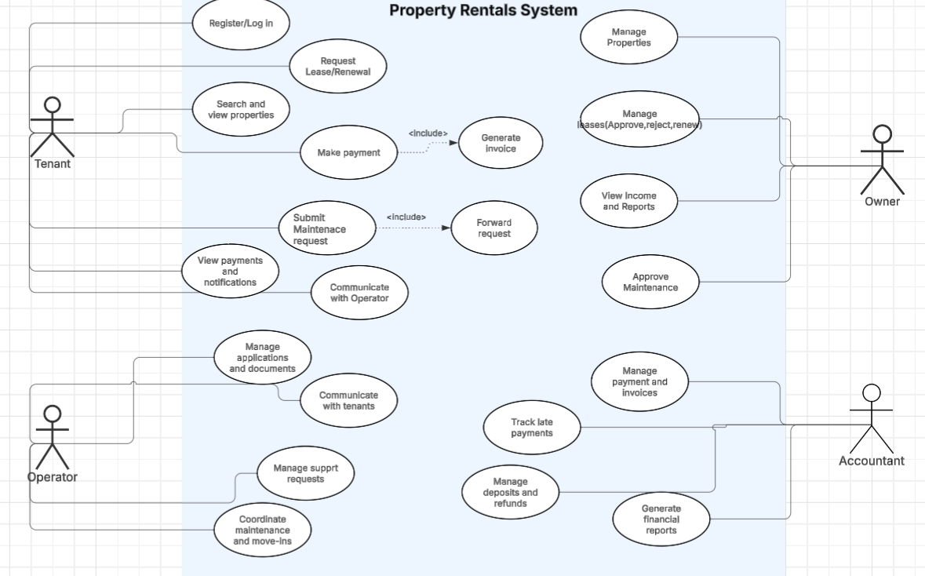

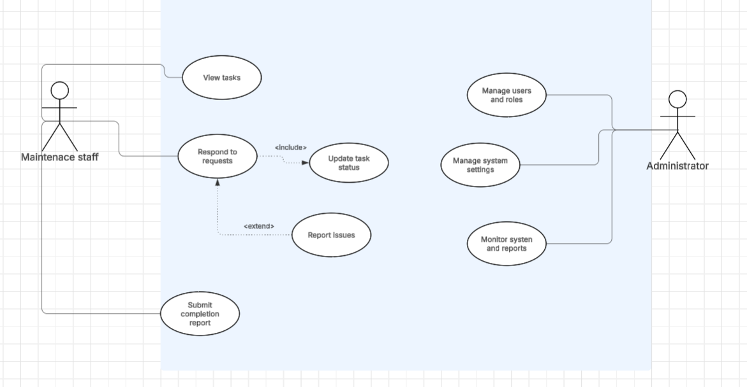
5.3 Activity Diagrams
AC043: Accountant generates invoices for tenants.

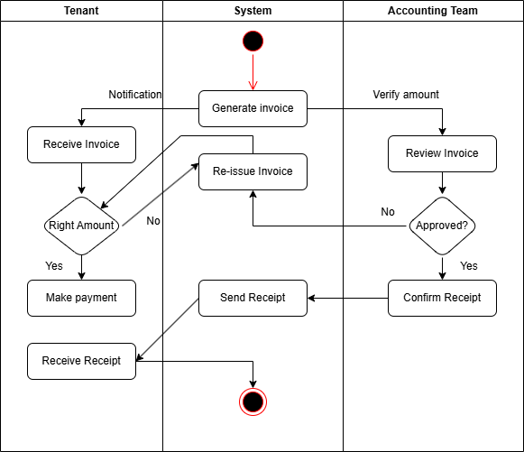

AC026: Tenant views property details
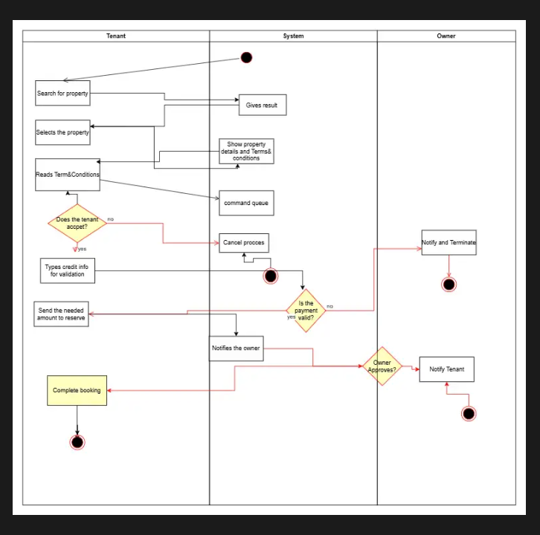

AC023: Tenant requests lease renewal
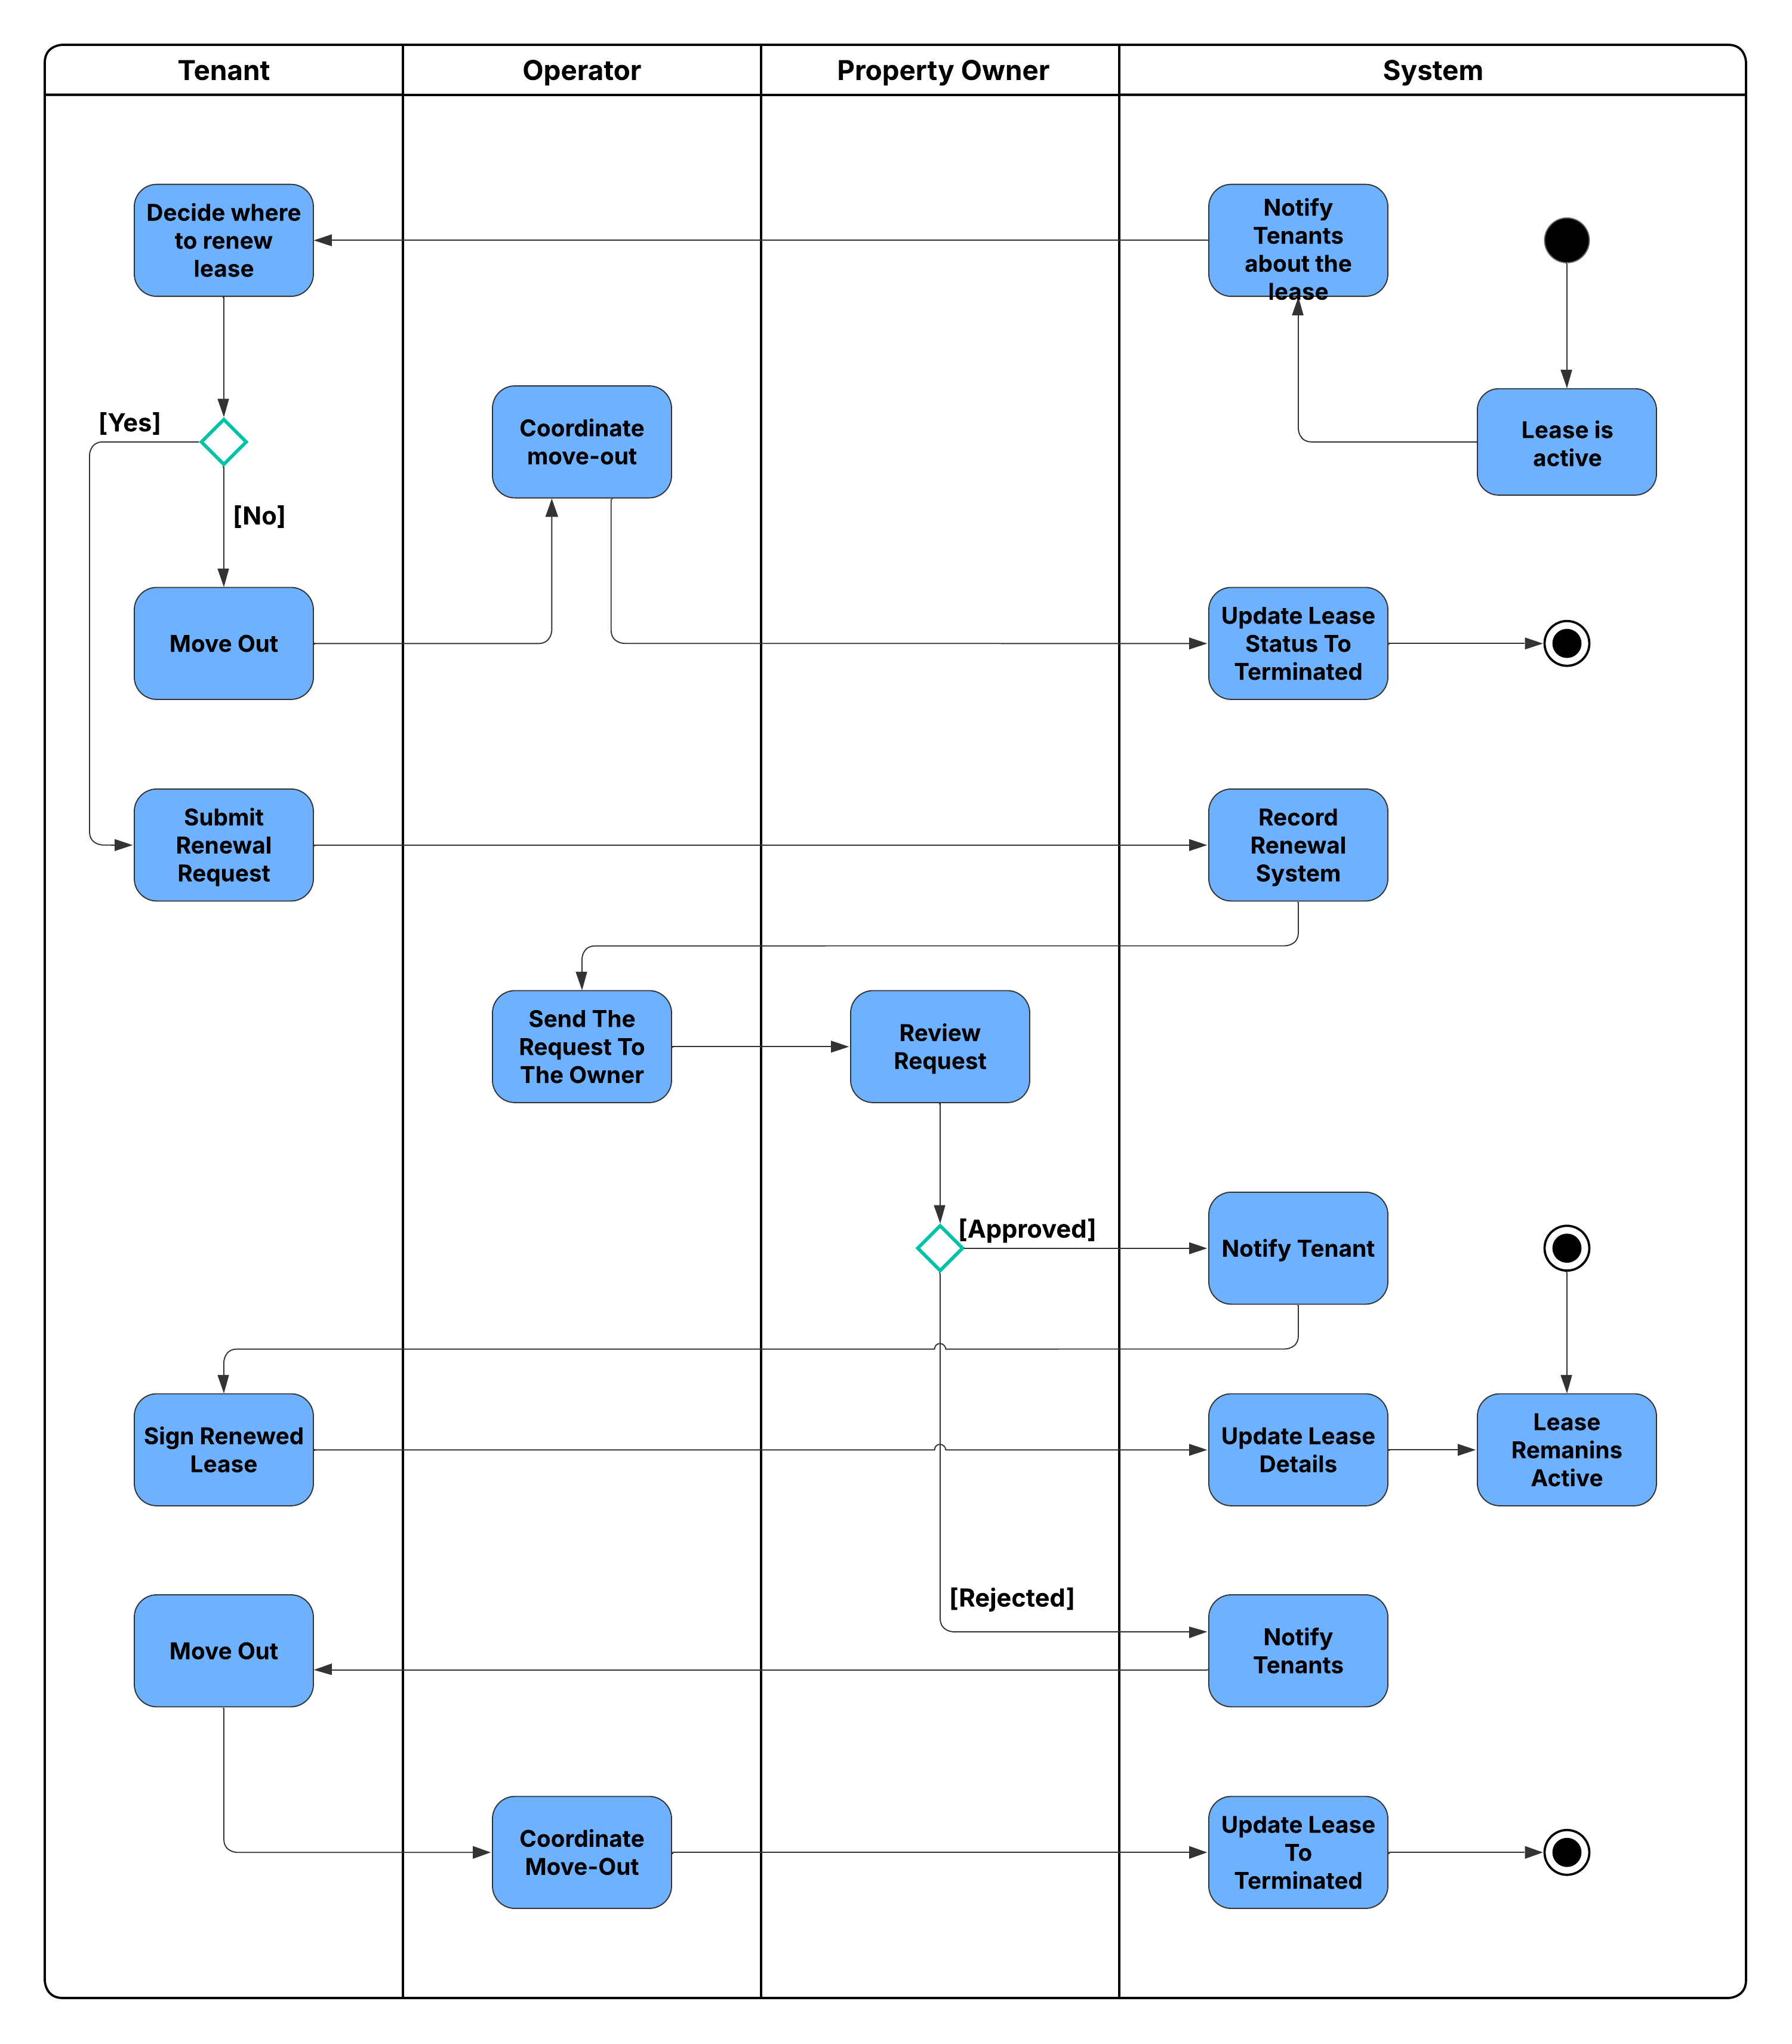

5.5 State Diagrams

Booking/Lease application
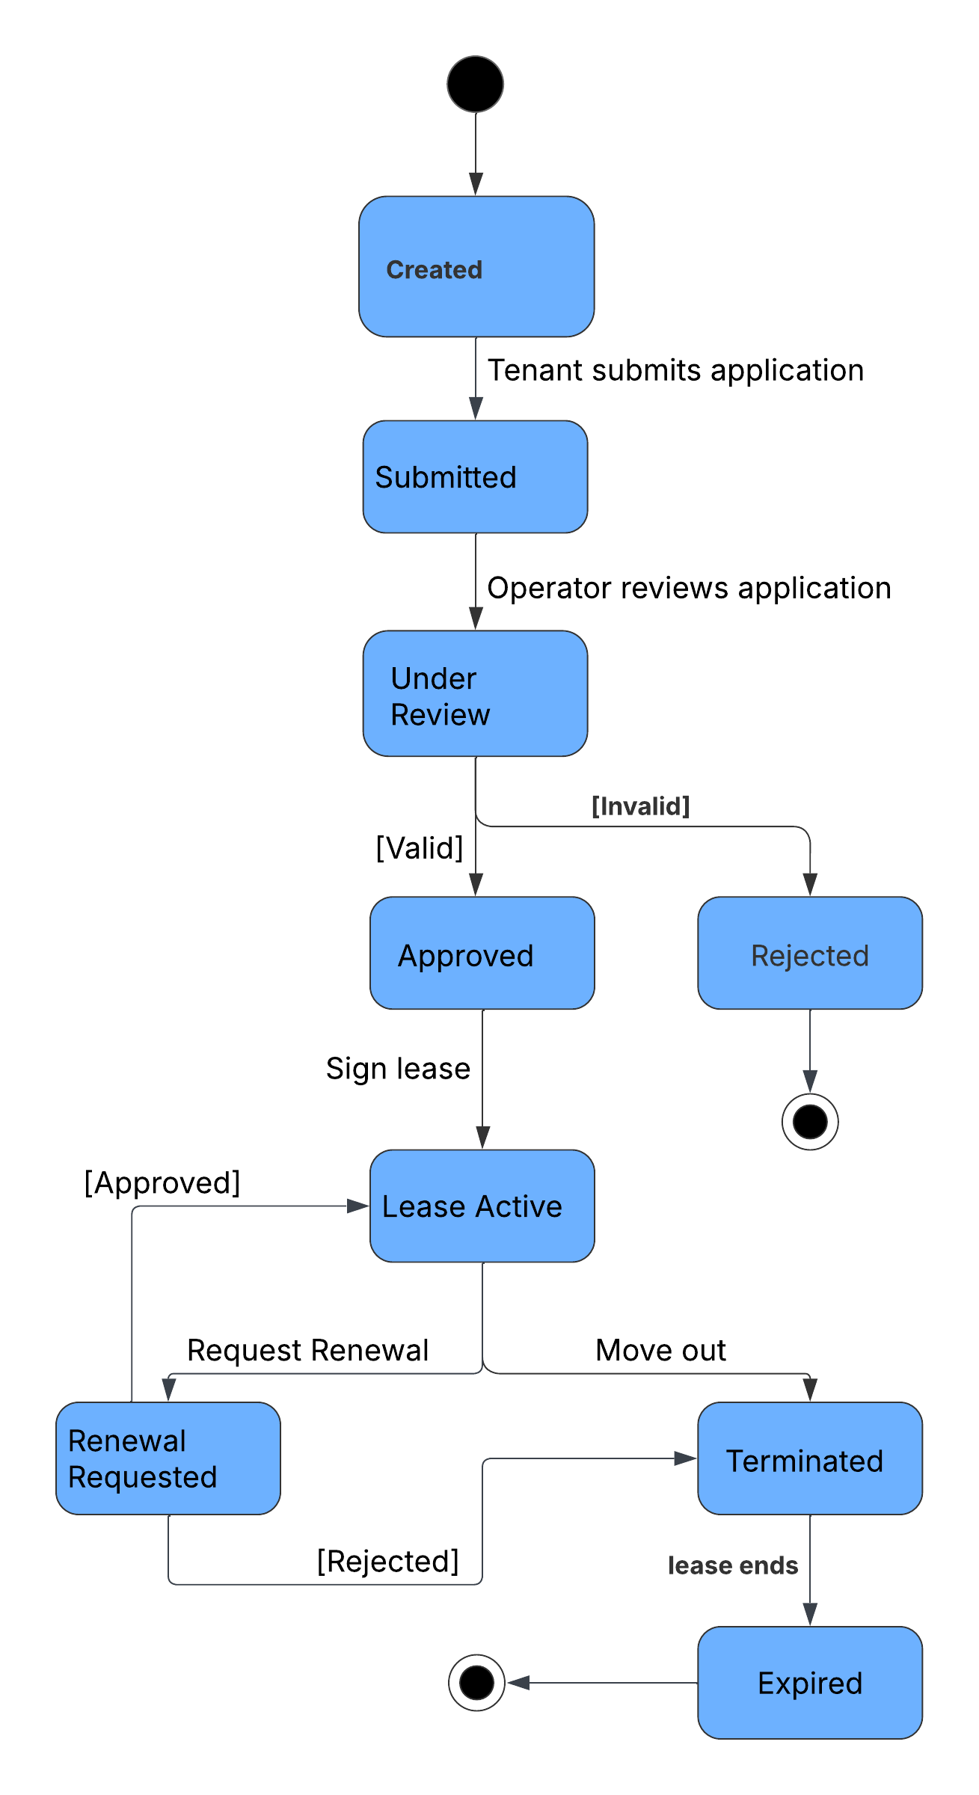

Maintenance request
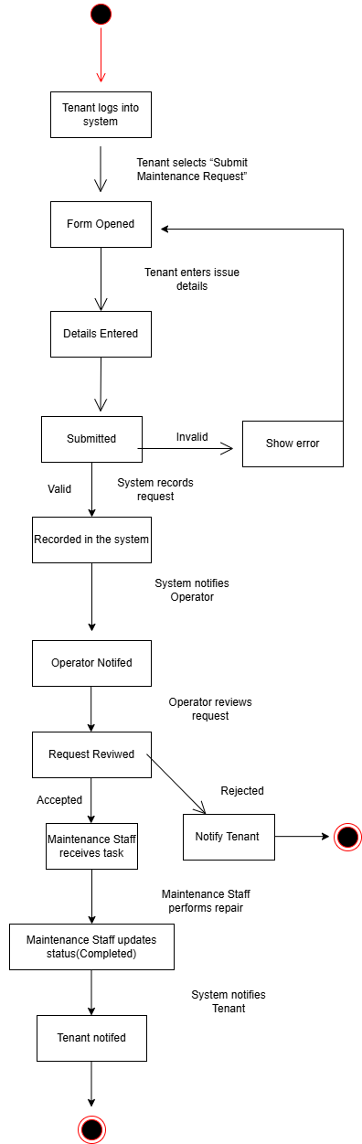

Payment

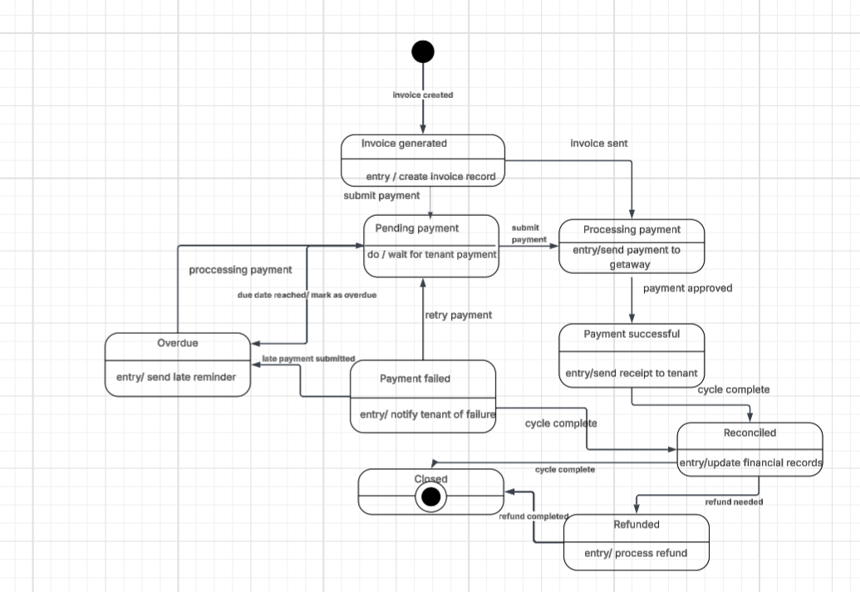

Property Listing
